CSCI 251 Assignment 2 Report
Prepared by Bryan Choo (7060452)

Table of Contents

Requirements of the program 3
Diagram / Illustrations of program design 3
Summary of implementation of each module 4
Shape 2D 4
Square / Rectangle 5
Circle 6
Cross 6
Sorting 7
Additional Feature 7
Reflections on program development (e.g. assumptions made, difficulties faced, what could have been done better, possible enhancements in future, what have you learnt, etc) 7

Requirements of the program
Looking at the program broken down into its requirements.
It needs to be able to take input from user. And from that input, it would have to create a unique object based on what the user has specified.
Classes would also need to be implemented for each of the specific objects that needs to be created
These classes would also need to exhibit polymorphic behaviors, and would have a parent “Shape 2D” class which it would inherit parts of the object from .

Diagram / Illustrations of program design

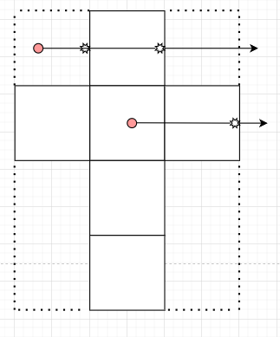
Fig.1 Ray Tracing Algorithm

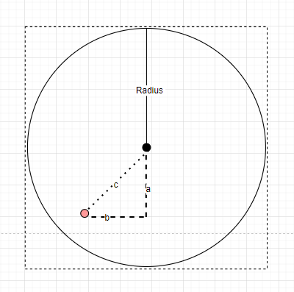
Fig.2 Points on/in circle

Summary of implementation of each module

Shape 2D

This is the parent class that contains most of the functions that will be called later on by its derived classes. There is not much code that is written inside this module beside simple constructor and getters and setter methods.

Square / Rectangle

In order to determine where a given point lies relative to the given square/rectangle. And as a matter of fact for all the shapes, the locations of the bottom left ( xMin, yMin ) and top right ( xMax, yMax ) have to be made known. This data is computed when the user is keying in the data points.
From this we can run a for loop to test all points along the shape and within the shape as well. Is point on shape ?
To determine if a given point is on the shape, we just need to see if the the given point any of the values lies on the xMin , xMax , or yMin , yMax.

Is point in shape ?
Since the for loop will be iterating for all points on and within the shape, we can reasonably assume that any point that is not on the shape is in the shape.
Which means that given any point xy, if x is not equal to the xMin and xMax or y is not equal to yMin or yMax. Such a point exists inside the shape.

Circle

Similar to how the rectangular shapes are computed, we need to draw a virtual square around the circle and use the bottom left ( xMin, yMin ) and top right ( xMax, yMax ) as an iterator as the smallest for loop that we have to go through to traverse every single point necessary for the circle computation. To determine what these points are we can use center +- the radius of the circle.
Is point on shape ?
To determine if a given point is on the shape, we just need to see if the point is one radius distance away from either the x or y,

Is point in shape ?
This has a much more interesting method to find the solution,
Since we are able to know that any shape that is one radius away from the center lies on the shape. We can further deduce that any distance from the center lesser than the radius would therefore mean that the point lies in the circle and if the distance is greater than the radius would like outside of the circle.
For a given point we just need to find out what is x and y difference from the center point. And using pythagoras theorem we can find out what is the shortest distance from that point to the center point. And by comparing it against the radius we can determine where the point lies relative to the circle.

Cross
To be able to iterate through all the points relevant to the cross, we first need to determine the bottom left ( xMin, yMin ) and top right ( xMax, yMax ) of the cross shape. And this input is similarly determined during user input.
Is point on shape ?
To determine if a given point is on the shape, we loop through all the vertices in the cross and we traverse every single point along it. And compare it to a given point.

Is point in shape ?
To be able to determine if the point lies within the cross, given that the cross shape can be unstandard. We will be using a generic ray tracing algorithm that is typically used in order to find out if a point exists in a polygon.

Ray Tracing Algorithm
This works by taking in the xy vertices of the shape and a given point and draws a horizontal line all the way to the right. And would then switch between 0 and 1. Depending on the number of times the line passes through an edge of the shape

Sorting
ASC/ DSC Sort
First creates a clone of the original shape array.
Uses the C++ sort function on this temporary vector with a custom lambda expression that is able to compare the areas of a given ShapeTwoD

Special Sort
First creates two temp vectors, one to store the WS shapes, and the other for the NS shapes
Loops through the original array and populates the two temp vectors
Uses the C++ sort function on both these temporary vectors with a custom lambda expression that is able to compare the areas of a given ShapeTwoD

Additional Feature

When displaying the summary for all the shapes. The program has a special additional feature where it is also able to display the average of all the shapes that have their area computed.
This would allow the user to get a better grasp of the nature of a shape that comes into their view. If this shape is larger or smaller than the average.

Reflections on program development (e.g. assumptions made, difficulties faced, what could have been done better, possible enhancements in future, what have you learnt, etc)
I quite enjoyed the task of creating this program as it builds upon the basics of C++ and with a better understanding of the language. It is easier to write code that works and understand the semantics.
It has also given me a better understanding on how encapsulation and polymorphism works and how it can be used in C++ syntax.
To be able to find out if a point lies within a certain shape was something that was really quite fun for me. To be able to think critically about what is the best way to solve this problem.
And even combining existing knowledge such as using pythagoras theorem to find the distance of a point to the center. That will determine the location of the point relative to the circle. Was a fun exercise to think critically.
However much time was spent trying to figure out how such an implementation can be used in order to determine a non standard shape like a cross. This was made more difficult by the sheer number of configurations that such a shape can take and there was no hereustic or unified method to determine a coordiate’s relativity to a shape.
Much time was spent trying to find out how this can be done. And it eventually led me to learn that this is a problem that is faced by many, and the problem is called point in polygon.
This has also led me to discover and learn about ray tracing algorithms in order to solve this problem.
There was definitely a steep difficulty curve from all the other shapes to the cross. And it has left me stumped for days before I was able to find the brain power and fortitude to try again.

